**BWT Task-04 Exercise**

**Submitted By: Abduhu Khan**

**Q1**

**Write a query to fetch all customer names and sort them alphabetically. (Topic Sorting)**

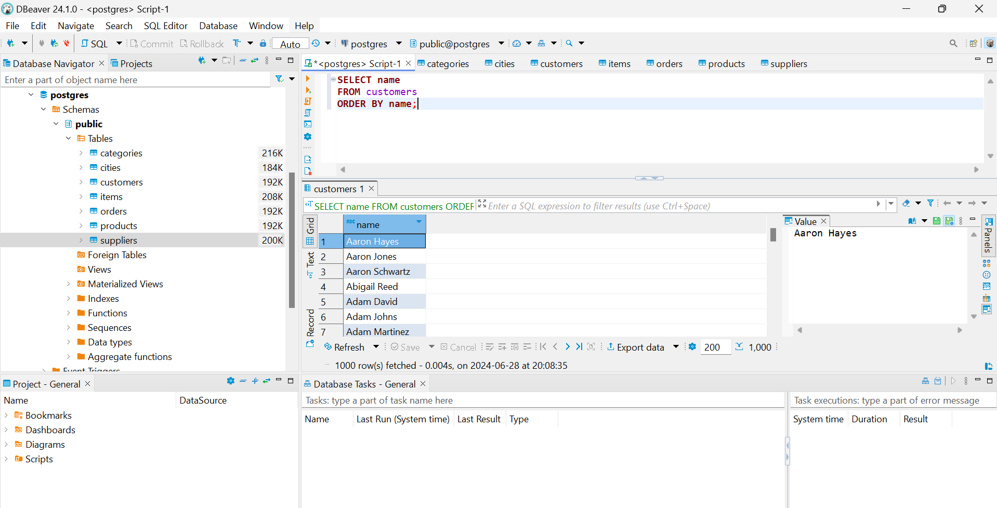

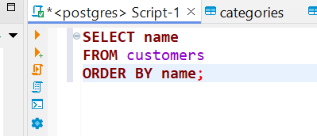

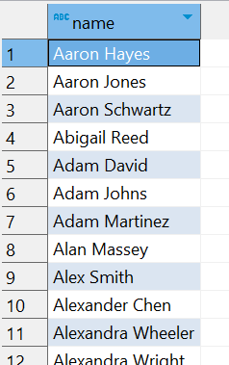

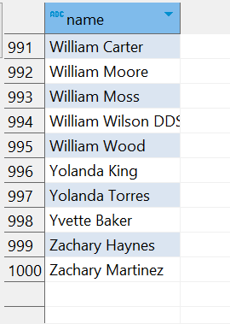

**Q2**

**Write a query to fetch all product names and their prices, sorted by price from low to high. (Topic Sorting)**

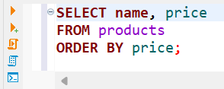

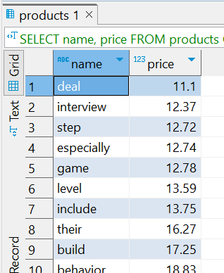

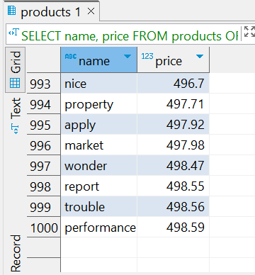

**Q3**

**Write a query to fetch supplier names that start with the letter 'A' and sort them by their names. (Topic Sorting with Operators and Wildcards)**

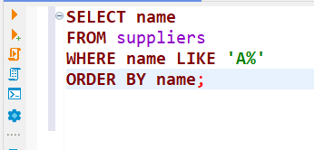

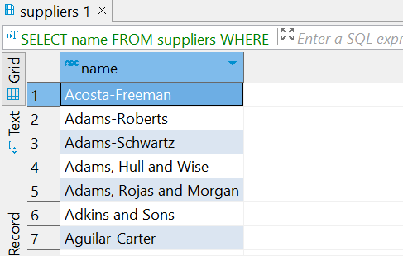

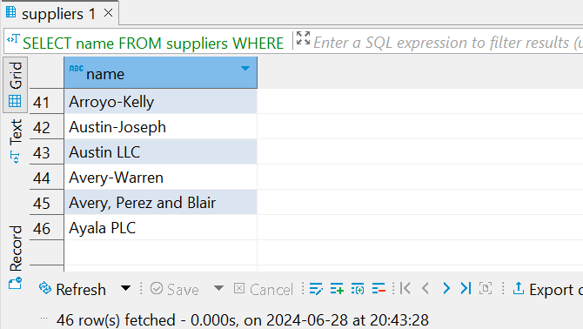

**Q4**

**Write a query to fetch all items and sort them by their status, placing NULL values first.**

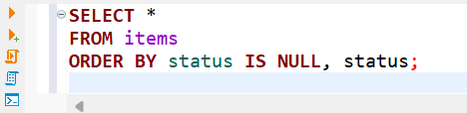

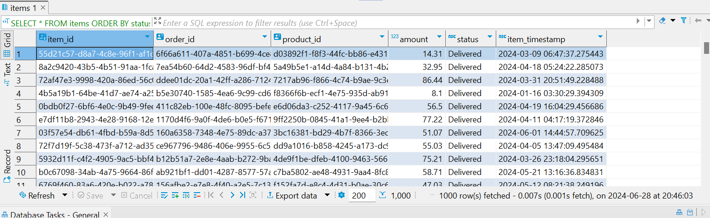

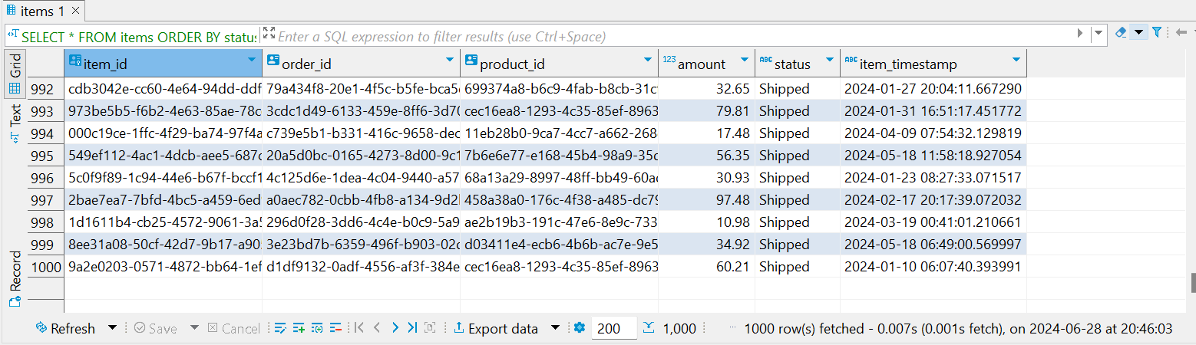

**Q5**

**Write a query to fetch all products, sort them first by category and then by price in descending order.**

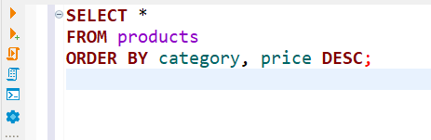

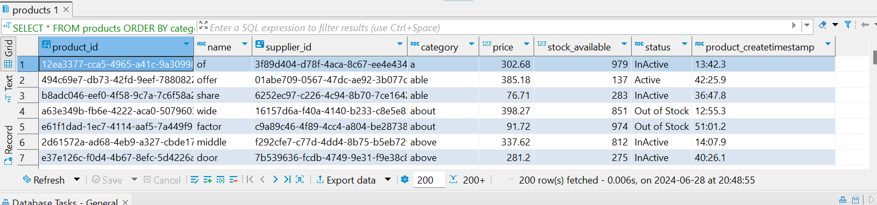

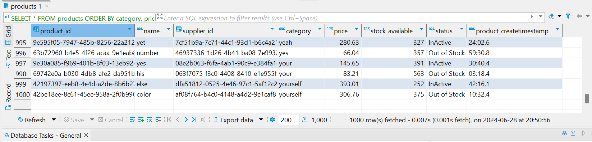

**Q6**

**Write a query to fetch all customer names and phone numbers, but sort them by the last four digits of their phone numbers in ascending order. (Hint use sorting with substrings)**

